**Database Systems**

**Fall 2020**

**LAB – 11**

**The objective of this lab is to:**

* Practice Single row functions
* DCL
* PL/SQL

**Course & Lab Instructor:** Sir Asif Sohail

Instructions:

* Work on this lab individually. Discussion is not allowed.
* Evaluation of tasks will be conducted in lab.
* Anyone caught being indulged in the act of plagiarism would be awarded an “F” grade in this lab.
* Evaluation will be considered final and you cannot debate for the marks. So, focus

on performing the tasks when the time is given to you.

* **Allowed time: 1 hour and 20 minutes**
* Best of Luck!
* **Kindly paste the query as well as result table screenshot as a result of each task**

**Sample:**

**Display All the Employees from emp table**

**Solution:**

**Select * from emp**

|  |  |  |  |  |  |  |  |
| --- | --- | --- | --- | --- | --- | --- | --- |
| **EMPNO** | **ENAME** | **JOB** | **MGR** | **HIREDATE** | **SAL** | **COMM** | **DEPTNO** |
| 7369 | SMITH | CLERK | 7902 | 12/17/1980 | 800 | - | 20 |
| 7499 | ALLEN | SALESMAN | 7698 | 02/20/1981 | 1600 | 300 | 30 |
| 7521 | WARD | SALESMAN | 7698 | 02/22/1981 | 1250 | 500 | 30 |
| 7566 | JONES | MANAGER | 7839 | 04/02/1981 | 2975 | - | 20 |
| 7654 | MARTIN | SALESMAN | 7698 | 09/28/1981 | 1250 | 1400 | 30 |

* **Perform the following tasks**

**Task 01: (DCL) [20 Marks]**

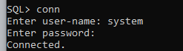

1. Create a user with your name.



1. Grant "connect" role to the user.

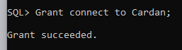

1. Grant SELECT privilege on EMP table to the user.

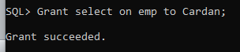

1. Login the user.

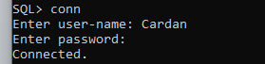

1. Access the EMP table.

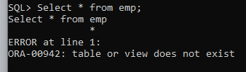

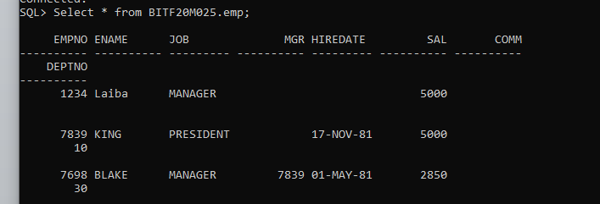

1. Create a synonym for EMP table.

While connected to system:

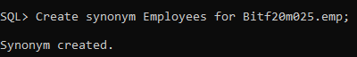

When connected to user:

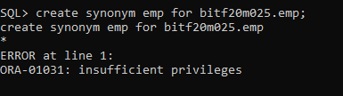

1. Delete a row from EMP table.

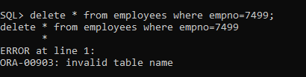

1. Login with your existing account.

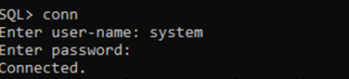

1. Revoke SELECT privilege on EMP table from the user.

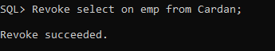

1. Login the user.



1. Access the EMP table to validate that SELECT privilege on EMP table has been revoked.

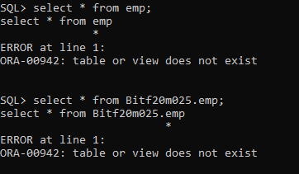

1. Login with your existing account.



1. Create a role "student"

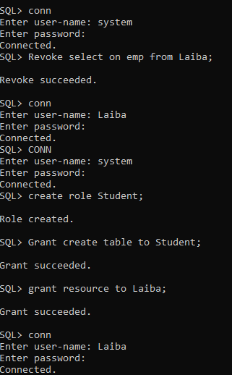

1. Grant "create table" permission to the role "student".



1. Grant "Resource" role to the newly created user.

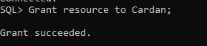

1. Login the user.

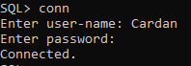

1. Create a temp table consisting of two columns.

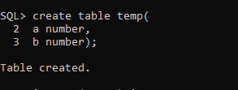

1. Insert a row in temp table.

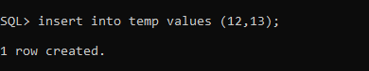

**Task 02: (PL/SQL) [20 Marks]**

1. Create a PL/SQL block that displays a message "My first program in PL/SQL".

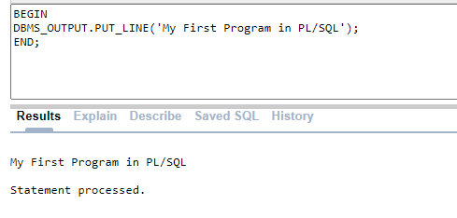

1. Write a program that receives a string and a number from the user and displays them on the screen.

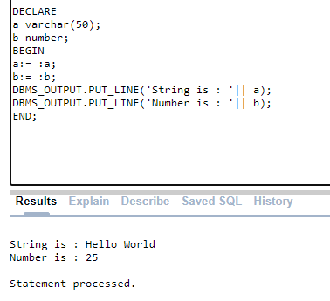

1. Write a program that retrieves ename and job of a certain employee and outputs the message in the format "SMITH is a CLERK".

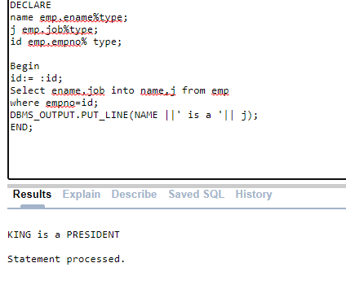

1. Write a program that retrieves comm of a certain employee and outputs the comm. The program should display "No Commission" for the employees whose comm is NULL.

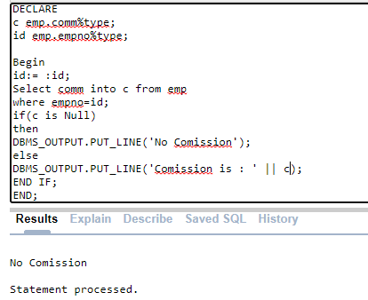

1. Write a program that retrieves sal of a certain employee and assign it to one out of three possible categories, "Low", "Average", or "High" on the basis of sal amount <1000, 1000 to 1500, and above 1500 respectively.

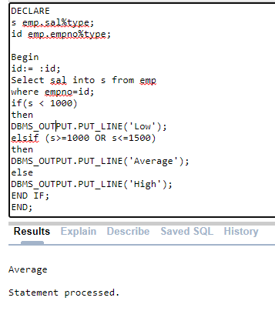

1. Extend the above program to handle an exception of "NO_DATA_FOUND".

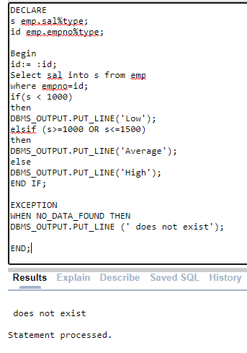

1. Take user’s marks of a subject as input and display his GPA and Grade (i.e A, A-, B+…) in that subject according to PUCIT policy. Make decision using SWITCH in PL/SQL.

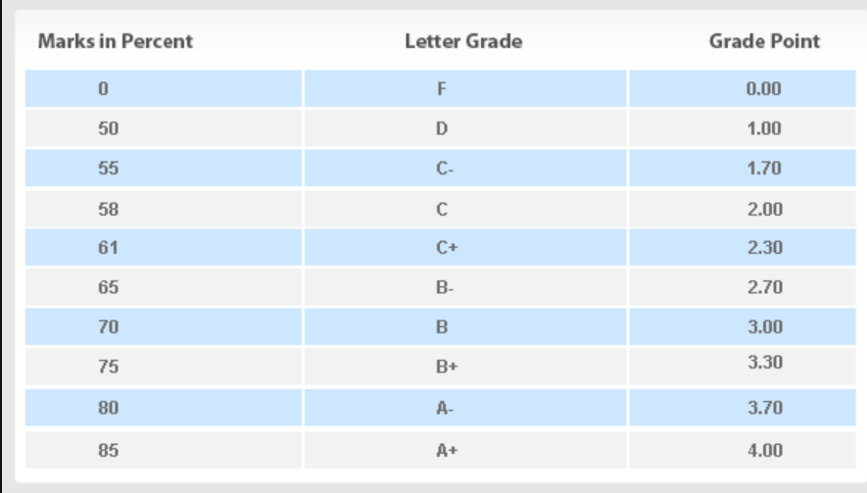

**DECLARE**

**i number(3);**

**gpa number(3,2);**

**grade varchar2(20);**

**Begin**

**i:= :i;**

**if(i<=100 OR i>=85)**

**then**

**gpa:=4.00;**

**grade:='A+';**

**elsif (i<=84 OR i>=80)**

**then**

**gpa:=3.70;**

**grade:='A-';**

**elsif (i<=79 OR i>=75)**

**then**

**gpa:=3.30;**

**grade:='B+';**

**elsif (i<=74 OR i>=70)**

**then**

**gpa:=3.00;**

**grade:='B';**

**elsif (i<=69 OR i>=65)**

**then**

**gpa:=2.70;**

**grade :='B-';**

**elsif (i<=64 OR i>=61)**

**then**

**gpa:=2.30;**

**grade:='C+';**

**elsif (i<=60 OR i>=58)**

**then**

**gpa:=2.00;**

**grade:='C';**

**elsif (i<=57 OR i>=55)**

**then**

**gpa:=1.70;**

**grade:='C-';**

**elsif (i<=54 OR i>=50)**

**then**

**gpa:=1.00;**

**grade:='D';**

**ELSE**

**gpa:=0.00;**

**grade:='F';**

**END IF;**

**DBMS_OUTPUT.PUT_LINE('GPA : '||gpa ||'Grade : '|| grade);**

**END;**

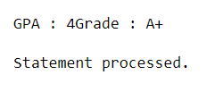

1. Take year as an input from user and decide its leap year or not.

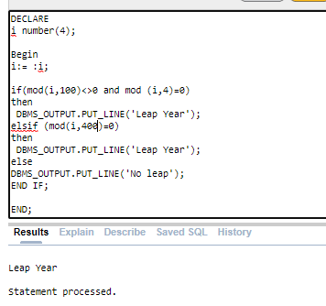

**************Best of luck***************